GENIUS Testing Plan
The following test plan outlines the test items and features to be tested once functional training has been completed. It has been designed as only a guide and is provided in a format for editing to suit an individual organisation’s requirements.

Contents
Test one – sending + signing service agreements 1
Test Two – managing invoices to NDIA 2
Test Three – managing invoices to Client/Plan manager (Service Providers only) 3
Test Four – managing engagements 4

Test one – sending + signing service agreements
To test sending + signing a service agreement
- Access your GENIUS client engagement
- Select ‘Edit’
- Expand ‘Service Agreement’
  - Select ‘Send agreement’
  - Select service agreement template
  - Select ‘Client/Representative’
  - Click ‘Send’
- This will open the electronic signature form
  - Select ‘Get started’
  - Select ‘Click to sign’
  - Insert signature
  - Select ‘Continue’ + ‘Confirm
- Upon signing, service agreement will send to the recipient for signing
- Recipient opens the form and signs from the email sent to them

Test Two – managing invoices to NDIA
Steps
There are a number of different types of invoices created in the NDIA invoice panel :
- Create a one - off invoice
- Create a recurring invoice
- Create a PocketWatch invoice (Service providers only)
- Generate bulk upload
- Reconcile invoice
- Sync invoice

To test managing invoices to NDIA managed claims
- In Invoice to NDIA, select ‘Create invoice’
  - Select the client
  - Enter start + end period
  - Enter due date (NB: leave this empty to create a draft bill when exporting to Xero/MYOB)
  - Select price book
  - Select the item code
  - Enter quantity
  - Click ‘Save’
- Approve the invoice
  - Approved invoices will automatically be added to the bulk upload file when it is generated
- Generate bulk upload file
  - Select ‘Generate report’
  - Select ‘NDIS Bulk Upload File’
  - Select ‘Generate’
  - NB: Do not change the name of this file. The bulk upload will generate with a filename convention YYYYMMDD000000.CSV.
- Upload the NDIS Bulk Upload file to the NDIA Portal
  - Once the bulk upload is complete, the NDIA should provide a Payee Payment Remittance Advice within 1-5 business days
  - The remittance advice will be used for reconciling payments in GENIUS
- Upon receiving Payee Payment Remittance Advice CSV from the NDIA, return to GENIUS
  - Select ‘Generate report’
  - Select ‘NDIA Reconciliation Report’
  - Select ‘Choose file’
  - Select the Payee Payment Remittance Advice CSV file
  - Select ‘Generate’
- On selecting ‘Generate’ the reconciliation is complete and a reconciliation results report will be generated
  - Open the Reconciliation results report
  - If the invoice was fully paid, column Q will show ‘TRUE’
    - These invoices will be treated as ‘NDIA Reconciled’
  - If the invoice was partially paid, column Q will show ‘FALSE’
    - These invoices will be treated as ‘NDIA Claimed + Gap’
  - If the invoice was not recognized as a GENIUS invoice, column Q will remain blank
    - This commonly occurs if the bulk upload filename was changed prior to uploading to the portal
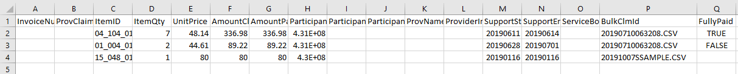
- Once reconciled, the invoice can be synced to MYOB/Xero
  - Select the invoice
  - Select ‘Sync selected'

Test Three – managing invoices to Client/Plan manager (Service Providers only)
Steps
There are a number of different types of invoices created in the NDIA invoice panel
- Invoice to Client/Plan manager
  - Create a manual invoice
  - Create a recurring invoice
  - Create a PocketWatch invoice
  - Send invoice
  - Reconcile invoice
  - Sync invoice

To test managing an invoice to the Client/Plan manager
- In Invoice to Client/Plan Manager, select ‘Create invoice’
  - Select the client
  - Enter start + end period
  - Enter due date (NB: leave this empty to create a draft bill when exporting to Xero/MYOB)
  - Select price book
  - Select the item code
  - Enter quantity
  - Click ‘Save’
- Approve the invoice
- Send the invoice
  - Invoices can be sent to the Client/Representative, Plan manager or yourself
- Once the invoice is paid it can be reconciled
  - Select ‘Filters’
  - Select ‘Status – Sent’
  - Edit the invoice
  - Enter ‘Amount paid’
  - Select ‘Save’
- Once sent, the invoice can be exported to MYOB/Xero
  - Select the invoice
  - Select ‘sync selected’

Test Four – managing engagements
When an engagement is approaching its expiry date, a renewal can be triggered. The renewal process is used to renew engagements, including schedules of support, service bookings + agreements. An engagement can also be expired if a plan is finished early.
Steps
- Renewing engagements
- Expiring engagements

To test managing engagements
- Navigate to the GENIUS Clients panel
- Select the ‘Renewal’ icon
  - The yellow renewal icon means a renewal has commenced and is currently pending approval
  - The blue renewal icon means a renewal has not yet commenced and is pending actioning
  - A green renewal icon means a renewal has been completed and is awaiting the new plan date to come into effect
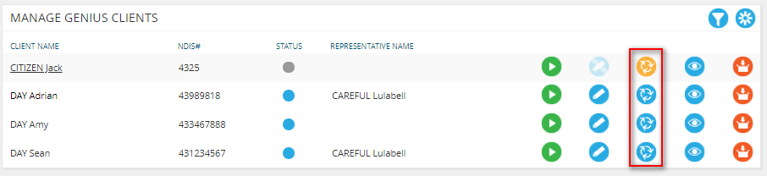
- Complete the engagement amendments for renewal
  - Ensure schedule of supports are renewed + finalized to match client’s needs
  - Ensure service bookings are up to date and match the NDIA portal
  - Ensure new service agreement can be generated and signed
- Upon completing renewal, the engagement will be active from the start date of the renewed plan and previous engagement expires

If a plan end date has been set incorrectly, it can’t be extended. In these circumstances, the engagement must be manually expired.

To manually expire an engagement
- Edit the engagement
- Set ‘Plan end date’ to a date in the past, e.g. the day the last plan ended.
- Click ‘Save + Close’

This will manually expire the engagement and a renewal can be triggered.

